**Internship Assignment Report: Cyber Security and Digital Forensics**

**Assignment 1: OS Fundamentals**

* **TryHackMe Rooms:**
  + Linux Fundamentals Part 1
  + Windows Fundamentals Part 2
  + Windows Fundamentals Part 3
* **HackTheBox Modules:**
  + Linux Fundamentals
  + Windows Fundamentals

**Assignment Overview**

* Welcome to my internship assignment report! This document highlights the cybersecurity and digital forensics challenges I've tackled as part of my Cyber Security and Digital Forensics internship with **CyberSecured India**. The focus of this report is on OS fundamentals, and it includes practical exercises completed on **TryHackMe** and **HackTheBox.**
* Through these assignments, I've had the opportunity to apply theoretical knowledge in real-world scenarios, hone my problem-solving skills, and gain hands-on experience with essential cybersecurity concepts. Each section will walk you through the tasks I've completed, showcasing the steps I took, the tools I used, and the insights I gained along the way.

#### ****Background and Prior Experience****

Before starting this internship, I had already completed several rooms on TryHackMe and HackTheBox. This prior experience gave me a solid foundation in cybersecurity principles and practical skills. During the internship, I continued to build on this knowledge by tackling new challenges and applying what I had previously learned in more complex scenarios.

**About Me**

* **Name:** Yugander Chanupalli
* **Position:** Cyber Security and Digital Forensics
* **Organization:** CyberSecured India
* **Email:** yugander9010@gmail.com
* **Submission Date:** 06/09/2024

**TryHackMe**

**TryHackMe Account Picture:**

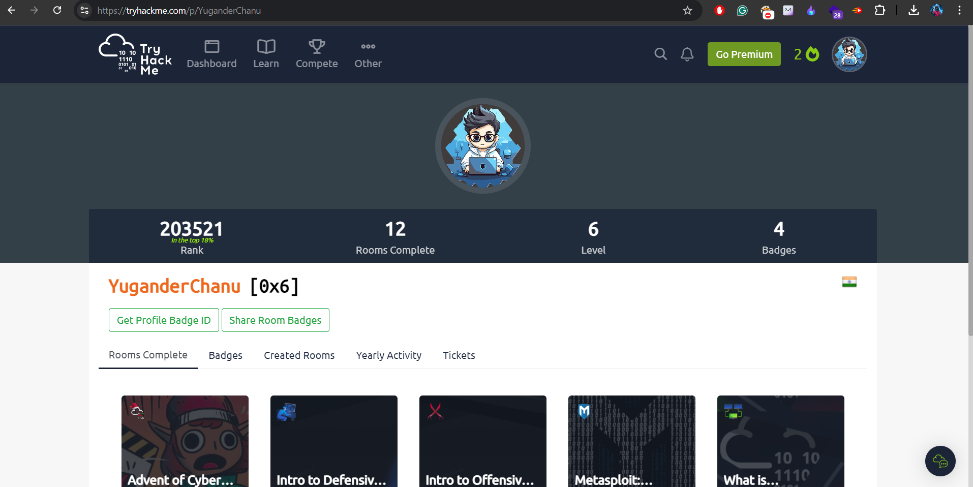

**Linux Fundamentals Part 1**

**Overview:**This room provided a solid introduction to the Linux operating system. I explored key concepts such as navigating the file system, understanding file structures, and basic system operations. It was a valuable starting point for getting comfortable with Linux.

**Topics Learned:**

* Navigating directories and managing files
* Basic Linux system operations and file structures
* Understanding and using fundamental Linux commands

**Screenshots:**

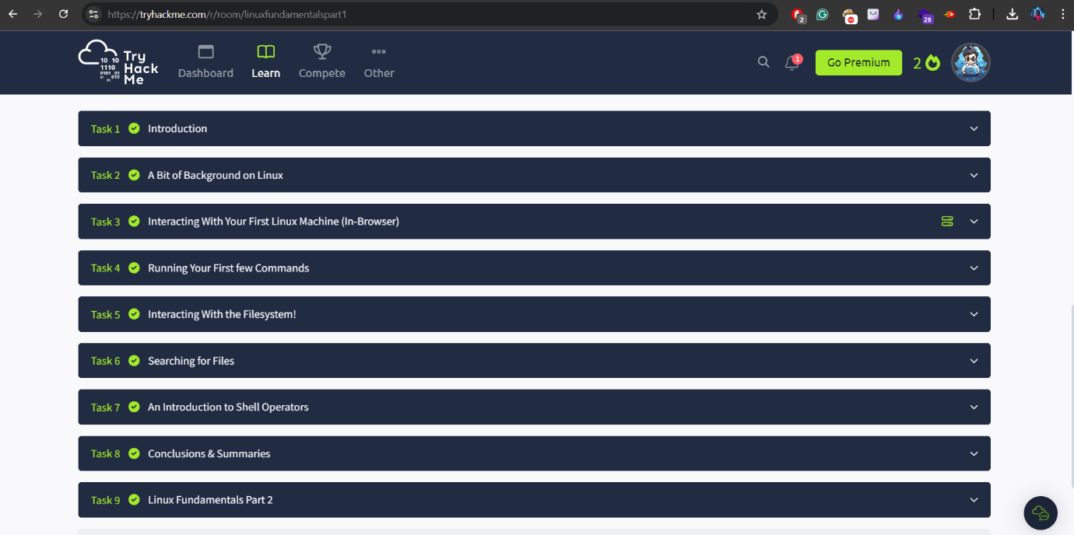 The image below illustrates the completion of Part 1 of my Linux Fundamentals part 1.

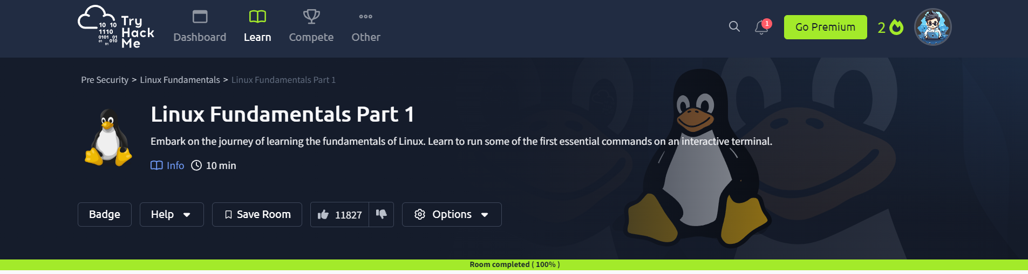

**Windows Fundamentals Part 2**

**Overview:**This room took me on a journey through the world of Windows system administration. I got my hands dirty with practical tasks that involved managing files and using command-line tools in a Windows environment. The exercises were crafted to boost my skills in navigating and configuring Windows systems, giving me real-world experience and making me feel more confident in handling system administration tasks.

**Topics Learned:**

* System navigation and file management
* Using command-line tools for administrative tasks
* Basic Windows system operations

**Screenshots:**

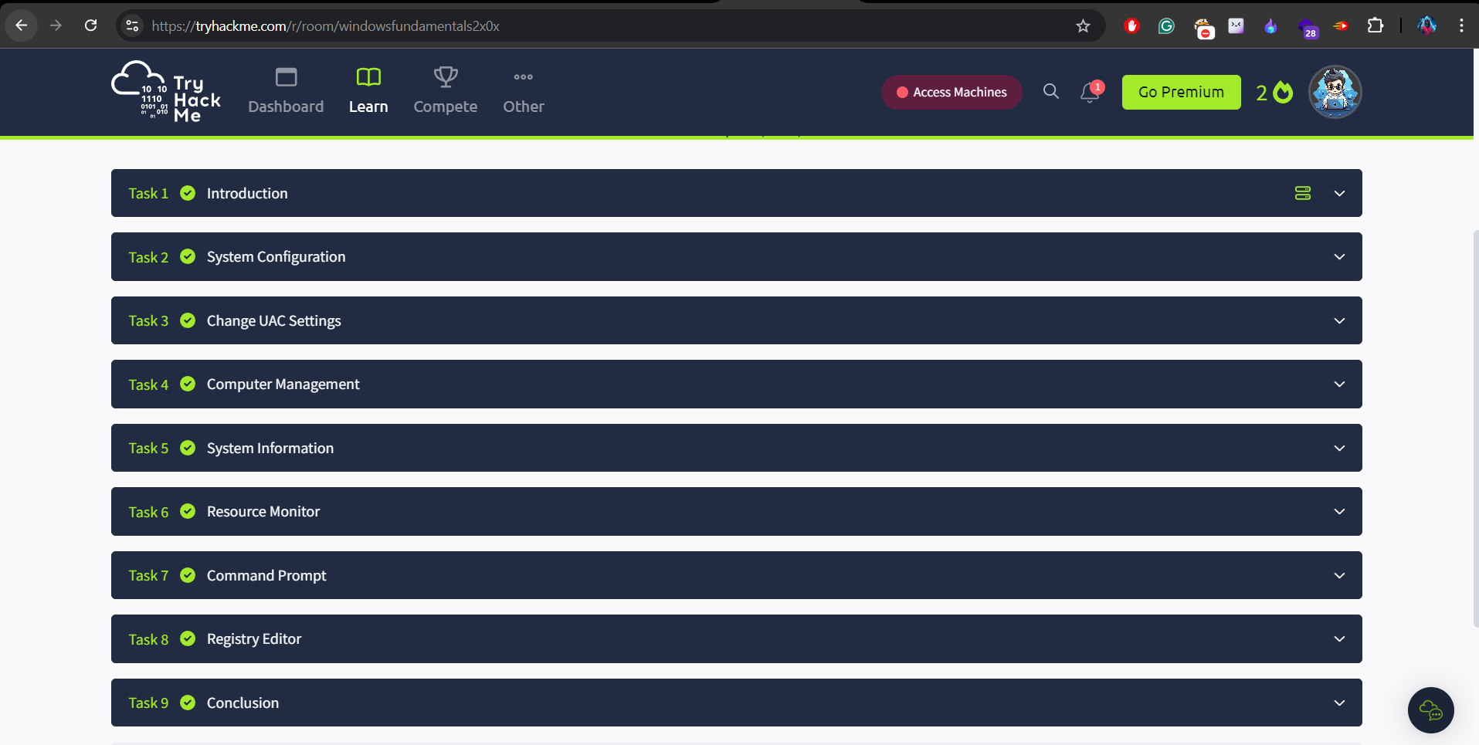

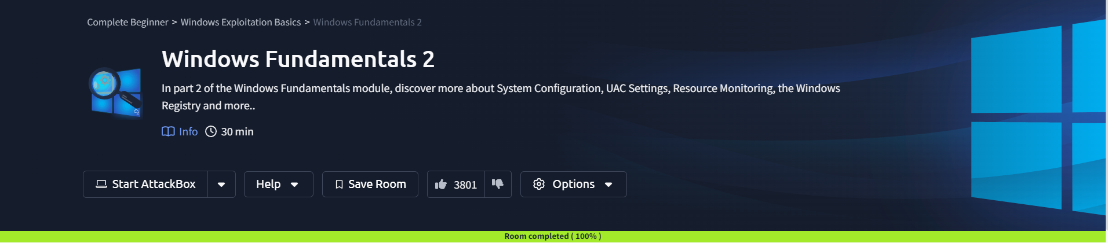

**Windows Fundamentals Part 3**

**Overview:**In this room, I tackled more advanced aspects of Windows system management, diving into critical topics such as user permissions and security settings. This experience was particularly valuable as it expanded my understanding of how to manage and secure a Windows environment effectively. I explored how to configure user access levels, handle security policies, and perform detailed file and directory management tasks. The room provided a comprehensive look into the intricacies of Windows system administration, equipping me with the skills needed to address more complex administrative and security challenges.

**Topics Learned:**

* Managing user permissions and system security
* Advanced file and directory management
* Configuring Windows security settings

**Screenshots:**

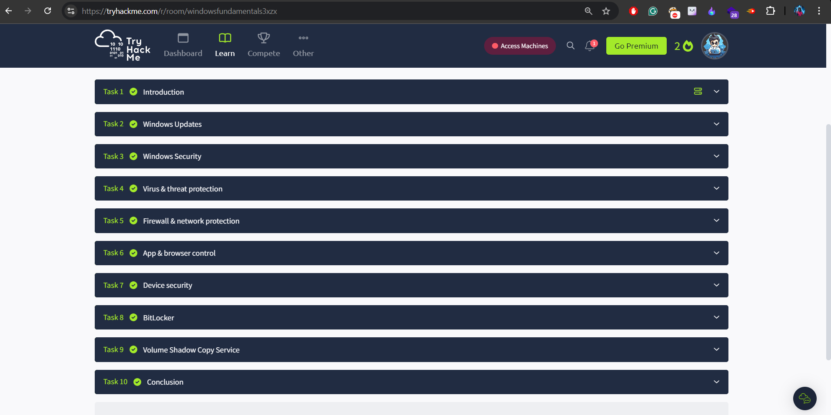

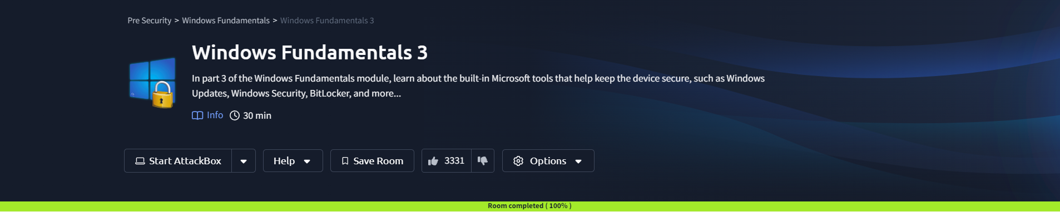

**HackTheBox Academy**

**HackTheBox Account Picture:**

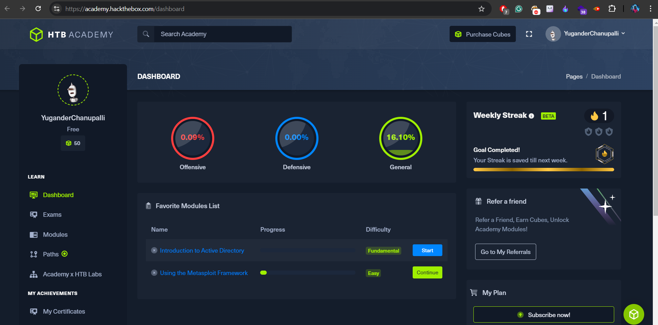

**Linux Fundamentals**

**Overview:**In this module, I took a deep dive into the essentials of working with the Linux operating system. The session gave me a solid introduction to Linux, focusing on the core aspects like understanding its structure, mastering the shell, and navigating the system. I got hands-on experience managing files and directories, which was crucial for learning basic Linux administration. I also tackled service management and permissions, which are vital for keeping the system secure and well-organized. This foundational knowledge not only helped me get comfortable with Linux but also set me up for diving into more advanced topics and sharpening my command line skills.

**Topics Learned:**

* Understanding Linux structure
* Using the shell effectively
* Navigating the Linux operating system
* Working with files and directories
* Basic Linux administration
* Managing services
* Handling permissions management

**Screenshots:**

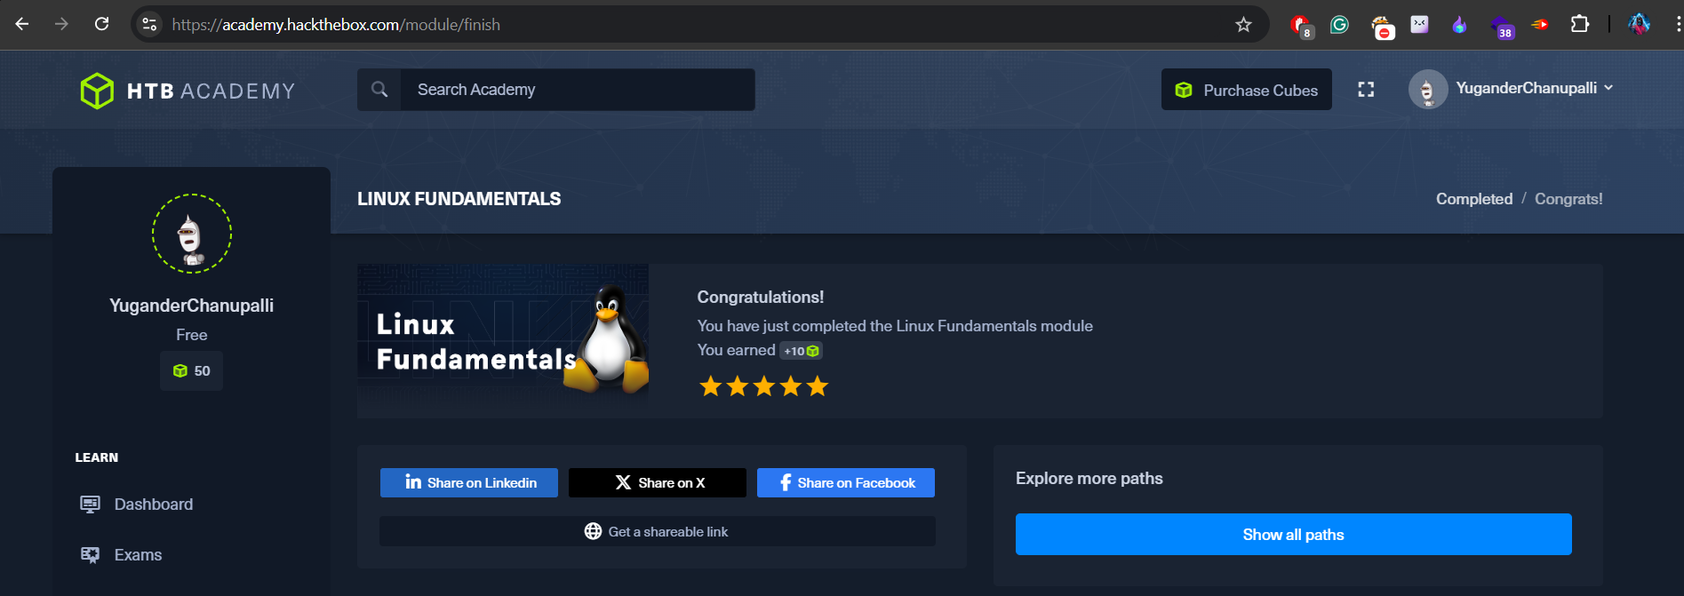

**Windows Fundamentals**

**Overview:**  
This module offered a deep dive into the core aspects of Windows system administration. It provided a solid foundation in working with the Windows operating system, including an introduction to the Windows structure, command line usage, and PowerShell. I gained practical experience in navigating the Windows environment, managing files and directories, and handling service management. Additionally, the module emphasized permissions management and Windows security fundamentals, which are essential for maintaining system integrity and security. This foundational knowledge prepares me for more advanced topics and enhances my overall proficiency with Windows systems.

**Topics Learned:**

* Understanding the Windows structure
* Using the command line and PowerShell effectively
* Navigating the Windows operating system
* Managing files and directories
* Handling service management
* Configuring permissions management
* Fundamentals of Windows security

**Screenshots:**

